Title of Extended Abstract (font size 14)

First name(s) Surname¹, Author²……………. (font size 12 italic)

¹Academy of Excellence…………… (font size 11)
²……………..
E-mail: au.thor1@domain.com; au.thor2@domain.com;.........(font size 11)

Short Abstract (font size 10 bold)

This abstract should be short – no more than 300 words……………. (font size 10)
Indent 1.25, no bullet points, no references in short abstract.

Keywords: 3-5 keywords to be used (font size 10)

1. Introduction and background (font size 12 bold)

Explain the background prior art briefly and move on to the targets of your work. Previous work by (Author, 2009)………….. (font size 11, full justify, single line spacing)

[1]

where A is the answer, B_{example} my example and γ_{i} the………………

2. Materials and Methods (font size 12 bold)

We describe how experiments were made using what and applying ……….. (font size 11, full justify, single line spacing)

2.1 Additives (font size 12)

In Table 1 we see show the…………… (font size 11, full justify, single line spacing)

Table 1: Materials used (font size 11 italic centred)

Materials

2.1.1 Formulating (font size 12 italic)

The formulation was………. (font size 11, full justify, single line spacing)

3. Results and Discussion (font size 12 bold)

In Figure 1…………….. (font size 11, full justify, single line spacing)

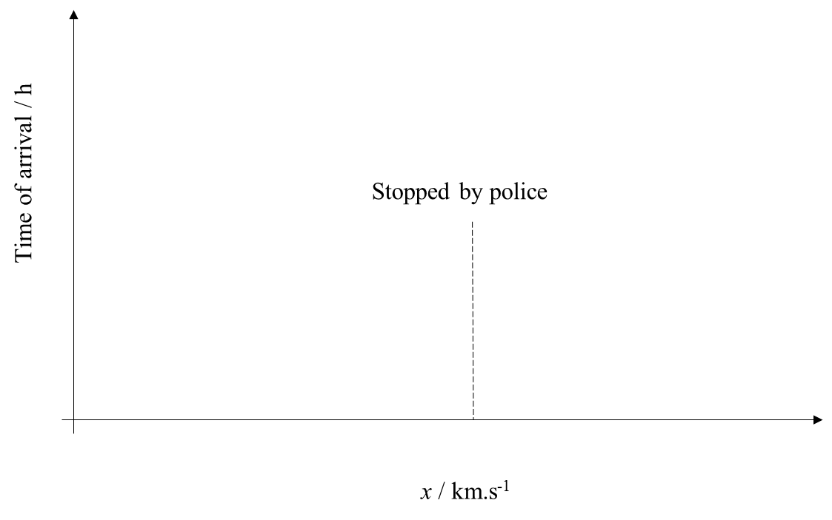
Figure 1: The reason why “more haste less speed” is true (Font size 11 italic centred)

4. Conclusions (font size 12 bold)

Conclusions are not a repeat of the findings, but short explanations why the findings support or negate the targets of the work…………….. (font size 11, full justify, single line spacing)

Total no more than 3 000 words.

Acknowledgements (font size 11 bold)

(font size 11, full justify, single line spacing)

References (font size 11 bold)

Author, A., Author, B. and Author, C., 2014. Making references……………….. . Progress in XY, 77(3), pp. 601-605

Bernard, D., 2013. Title in italics. City: Publisher…………..

Cuthbert, G., 2002. Knowing how to reference. In: Editor, I., eds. Proceedings of the most famous, Publisher, 18pp

Author list (font size 10 full justify) - list in alphabetical order

Olkkonen, J., Lehtinen, K. and Erho, T., 2011. Flexographically Printed Fluidic Structures in Paper. Analytical Chemistry, 82(24), pp. 10246-10250.

Carpi, F., Smela, E., Li, Z. and Cheng., Z., 2009. Piezoelectric and electrostrictive polymer actuators: Fundamentals. In: Biomedical Applications of Electroactive Polymer Actuators, John Wiley & Sons, Ltd, pp. 317–334

